Hiking photos

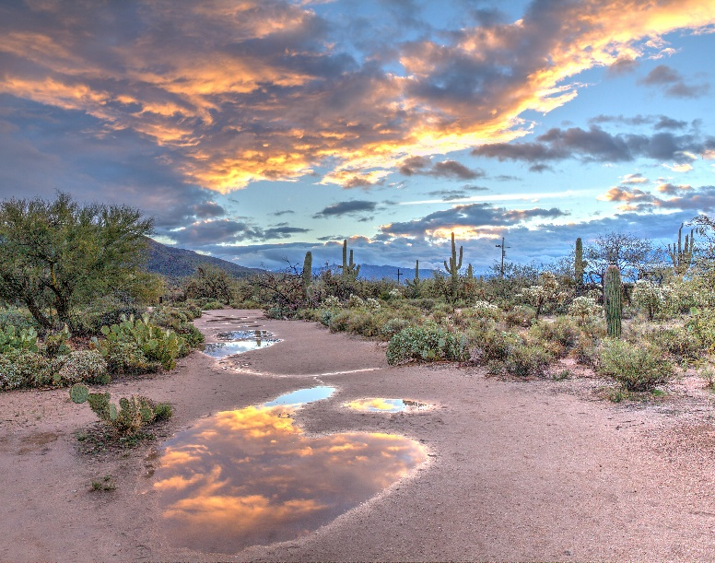

dulcey-lima-1346068-unsplash.jpg

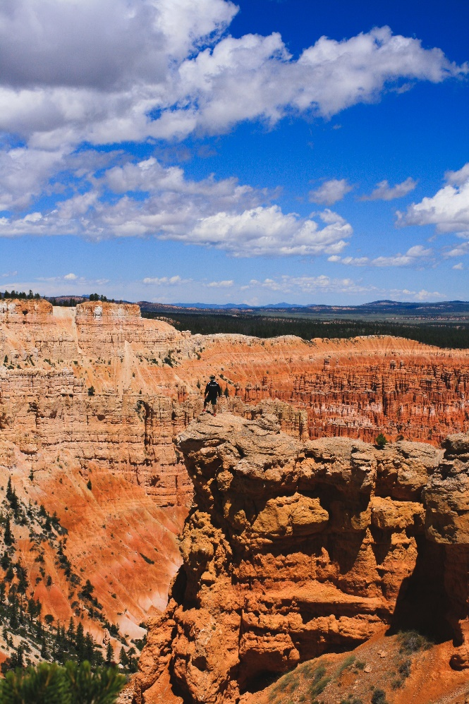

Forrest-moreland-119862-unsplash.jpg

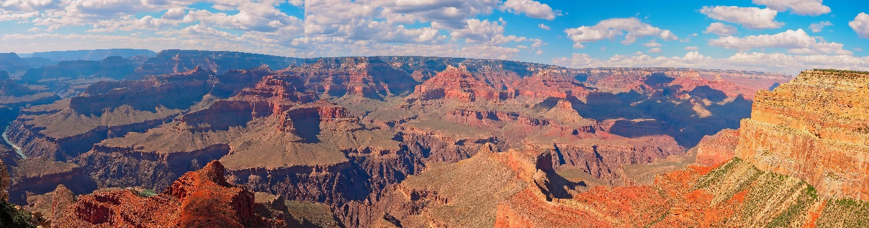

Michael-rodock-1356514-unsplash.jpg

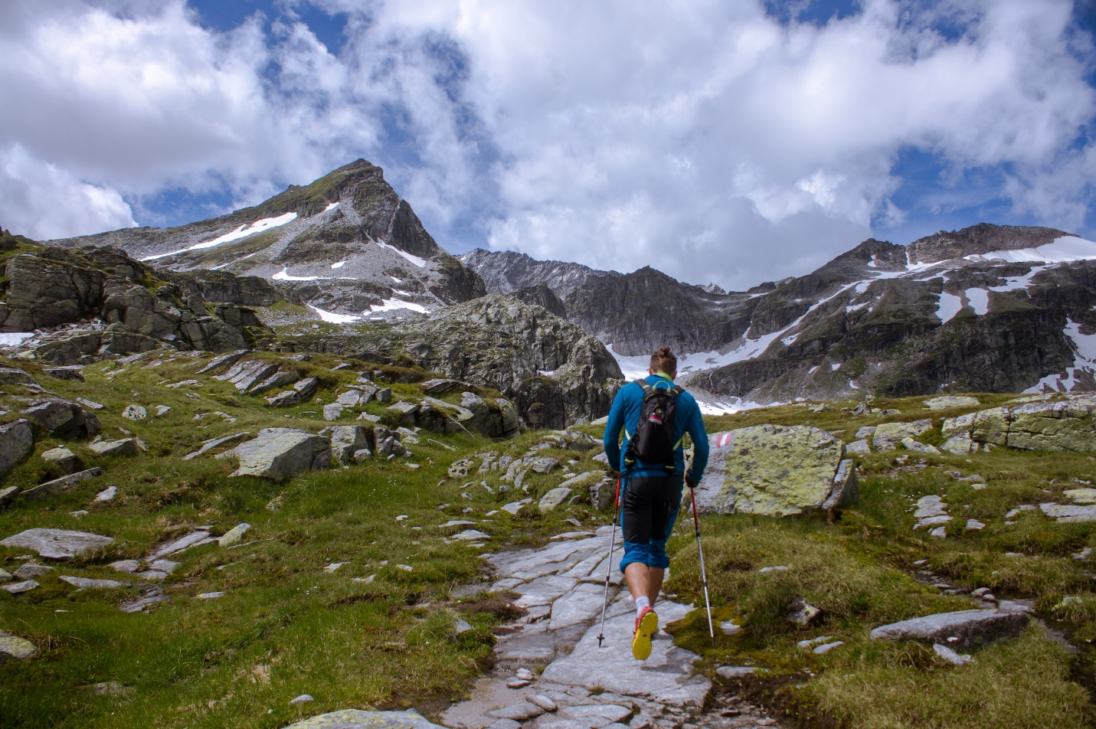

Jan-niclas-aberle-309470-unsplash.jpg



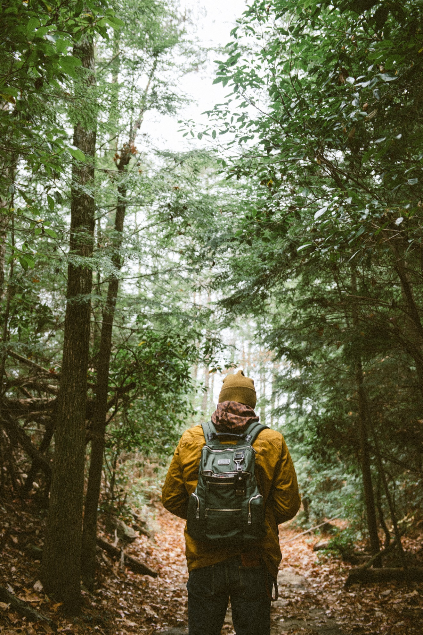

Chad-madden-171246-unsplash.jpg

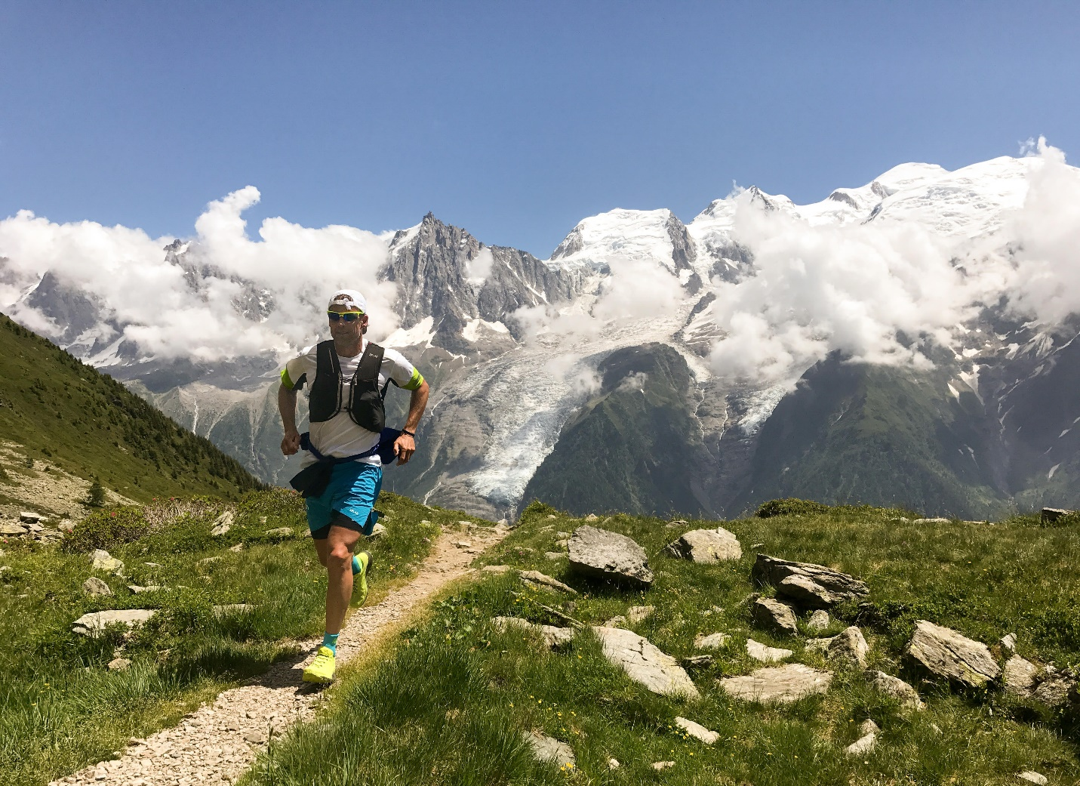

Brian-metzler-296165-unsplash.jpg

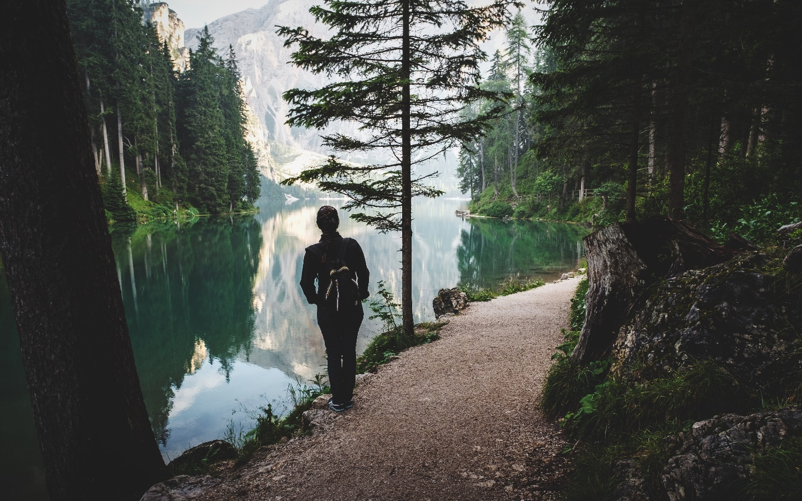

Luca-bravo-190269-unsplash.jpg







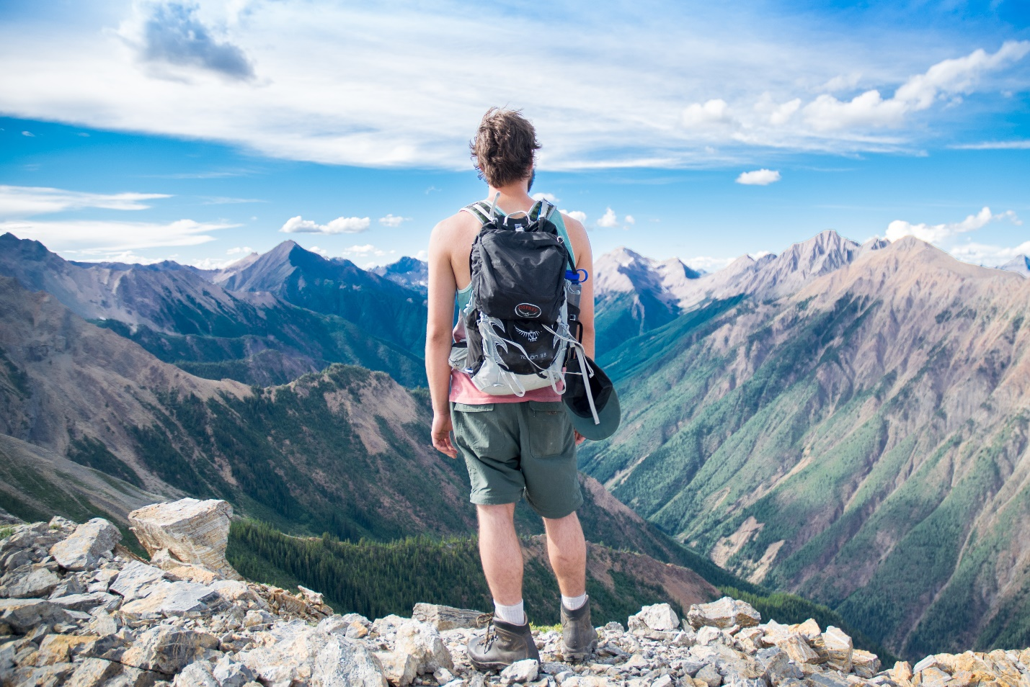

Photo by [Chris Hayashi](https://unsplash.com/@chris_hayashi?utm_source=unsplash&utm_medium=referral&utm_content=creditCopyText) on [Unsplash](https://unsplash.com/search/photos/mountain-hiking?utm_source=unsplash&utm_medium=referral&utm_content=creditCopyText)

Chris-hayashi-121340-unsplash.jpg

Photo by [Chris Hayashi](https://unsplash.com/@chris_hayashi?utm_source=unsplash&utm_medium=referral&utm_content=creditCopyText) on [Unsplash](https://unsplash.com/search/photos/mountain-hiking?utm_source=unsplash&utm_medium=referral&utm_content=creditCopyText)







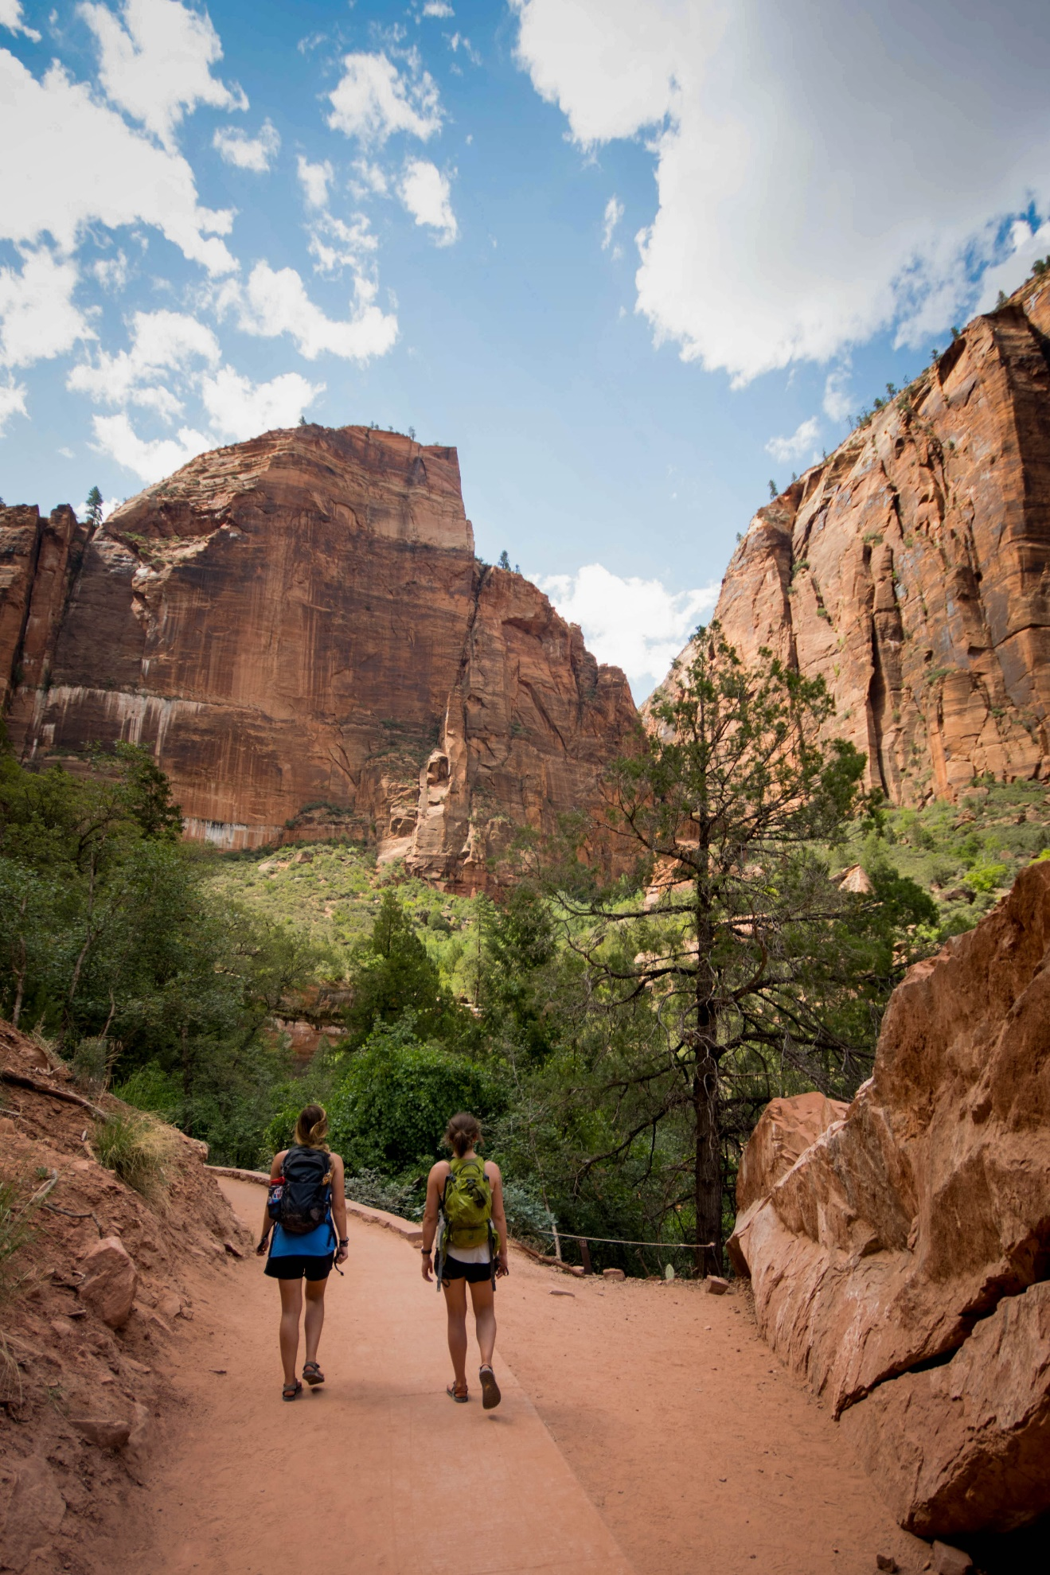

Photo by [Frances Gunn](https://unsplash.com/@francesgunn?utm_source=unsplash&utm_medium=referral&utm_content=creditCopyText) on [Unsplash](https://unsplash.com/search/photos/mountain-hiking?utm_source=unsplash&utm_medium=referral&utm_content=creditCopyText)

Frances-gunn-791888-unsplash.jpg

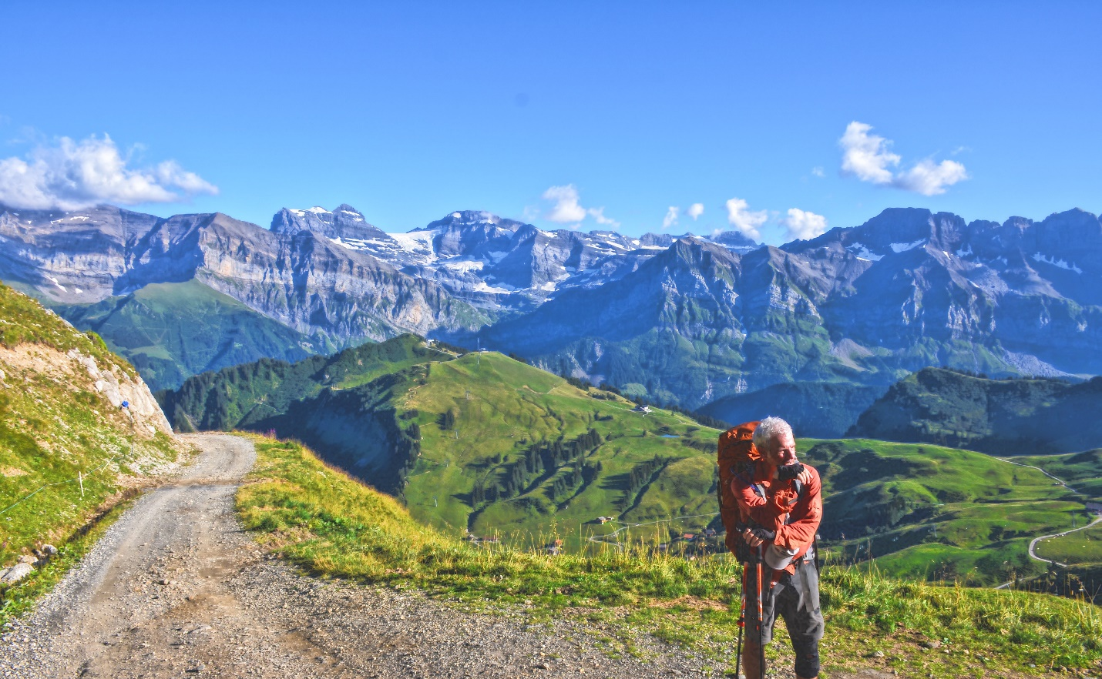

Photo by [Colton Miller](https://unsplash.com/@millerco?utm_source=unsplash&utm_medium=referral&utm_content=creditCopyText) on [Unsplash](https://unsplash.com/search/photos/mountain-hiking?utm_source=unsplash&utm_medium=referral&utm_content=creditCopyText)

Colton-miller-700463-unsplash.jpg





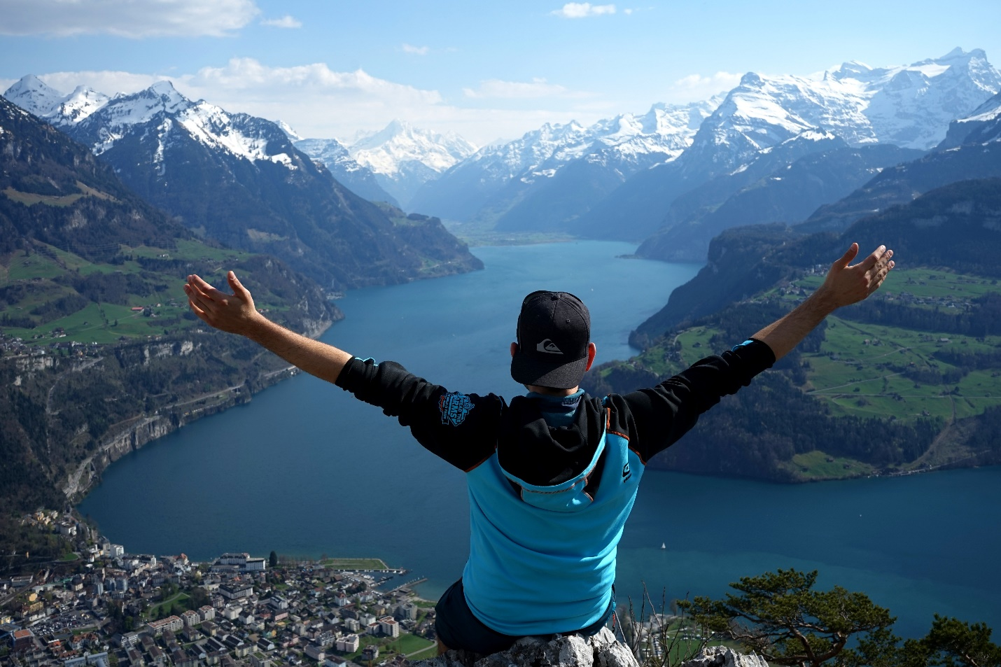

Photo by [Seb Mooze](https://unsplash.com/@mrcalvert?utm_source=unsplash&utm_medium=referral&utm_content=creditCopyText) on [Unsplash](https://unsplash.com/search/photos/mountain-climbing-people?utm_source=unsplash&utm_medium=referral&utm_content=creditCopyText)

Seb-mooze-1529852-unsplash.jpg

